**X-Prize Hybrid Gas-Electric Power System**

**Hayes Griffin, Frank Jones, Ernesto de Losada, and Henry Meiring**

ECE 496 (and ME 424)

Instructors: Dr. Brooke and Dr. Simmons

Duke University

Due: March 24th, 2017

**Overview**

The following report presented by the Duke Spring 2017 X-Prize Hybrid Gas-Electric Engine Group will contain background information on both the hybrid system and the broader project, an update on the progress made since the current team took over the project, as well as future plans and goals that The Group hopes to achieve during the remainder of the semester. The design for the power system employs a gas engine coupled to a DC motor, and a significant amount of torque is generated. As inherited, the system was mounted on a test frame that is not sufficient for connection to the drone body and flight. The main mechanical challenges have been and will continue to be designing and machining proper shafts and couplings for the engine and motor which can handle the generated torque, as well as building a lightweight sturdy frame which can be mounted on the drone.

**Competition**

The Shell Ocean Discovery X-Prize is a global competition to find a more efficient way of producing high resolution bathymetric maps of the ocean floor. The competition consists of designing a semi-autonomous device that can be launched from shore or air and is able to map 500 square kilometers of the ocean floor at depths of 2000 and 4000 meters in a limited number of hours. The grand prize is $4 million and teams can also compete for the NOAA bonus prize of $1 million awarded to the team that successfully finds and identifies the source of a chemical signal.

**Motivation**

Current technologies for ocean mapping are not easily scalable. Covering the entire ocean floor with them would demand compromises in resolution, coverage, power consumption and sensor weight. In addition, present-day ocean floor mapping requires capital investments upwards of $1 million and operating costs exceed $60,000 per day.

Despite the importance of the ocean on our planet and economic activities, only a fraction of government, academic and private investment is allocated to deep ocean exploration. The Shell Ocean Discovery X-Prize aims to stimulate the market for bathymetric exploration technologies; jumpstarting innovation and creating demand for information about the world’s oceans.[1]

**Entire Drone System Background:**

In order to complete the mission, the team decided to design and construct an 18 rotor heavy lift drone equipped with a hybrid powertrain to deliver a synthetic aperture solar diving pod capable of collecting the required data points. The pods are hermetically sealed and equipped with a 28 kHz sound system for SONAR, a variable buoyancy diving system, IMU and GPS based positioning sensors, WiFi and LoRa for module data communication, and a chemical signature sensor.

To tackle such a large mapping area, the drone will drop the pod at a predetermined starting location and the pod will then sink to the required depth and collect a set of data points. It will then rise to the surface and the drone will retrieve it from the ocean and transport it to the next measurement location.

Electric motors are the often used in drones for their superior RPM flexibility compared to gasoline engines but are limited in range due to the relatively low energy density of the batteries that power them. To overcome this hurdle, the drone will be equipped with three gasoline powered generators. The generator setups are composed of a DLE-60 Twin 60cc two stroke model aircraft engine and a Turnigy 80cc Outrunner BLDC brushless motor. The gasoline and electric motors are coupled via two turned steel shafts and a high strength lovejoy joint. The hybrid power system allows for an extended flight time of up to several hours.

**Hybrid System Background:**

The hybrid power system consists primarily of a DC brushless motor/generator coupled to a twin cylinder engine. Two LiPo batteries are supply power to the motor in order to start the engine. With the engine started, the motor then acts as a generator, receiving mechanical power from the engine and converting it to electrical current which flows through a rectifier and charges a third battery. Below is a block diagram depicting the power flow of the hybrid system[2]:

**Figure 1.** A block diagram of general power flow in the hybrid gas-electric power system.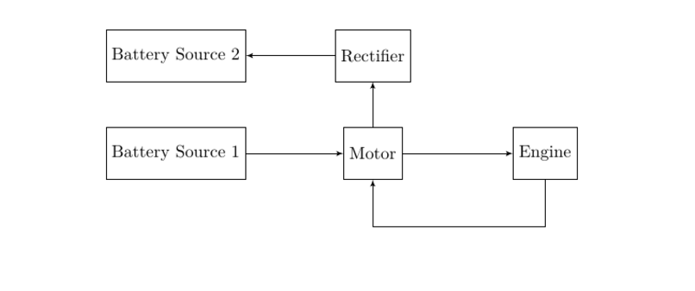

In addition to the engine, motor/generator, and battery sources, the full hybrid power system is comprised of the following components:

* Ignition Box
* Battery Eliminator Circuit
* Servos
* Arduino Microcontroller
* Adafruit shield
* Rectifier subcircuit
* Current Sensor
* Gas tank
* Temporary frame

The ignition box fires the spark plugs of the engine. The battery eliminator circuit provides power at 5 V to the Arduino and the ignition box. Two servos connected to the engine control the choke and throttle (to set the air/gas mixture used in the engine). The Arduino microcontroller runs the code to control the engine and generator. The rectifier subcircuit takes AC power generated from the motor/generator and converts it into DC power capable of charging a LiPo battery. A full schematic of the system’s components and their connections can be seen in **Appendix A.**

As inherited, the system was mounted on a temporary frame for testing but unable to be run. From a mechanical standpoint, the engine/motor coupling was insufficient for handling the appropriate amount of torque. The Lovejoy coupling used did not have a high enough rating, and the connection choice of set screws left both the generator and engine shafts chewed up and mangled.

Additionally, the shafts themselves were too small. The engine shaft that was being used for the coupling was actually not intended for transmitting significant torque and was only screwed in on the rotating component of the engine that is capable of transferring the torque. For these reasons, both shafts would need to be replaced with custom steel shafts, and the coupling had to be totally redesigned with a higher rating and keyways that serve as much higher quality connections.

**Progress**

We began our efforts by trying to start the engine using the generator as the starter. As inherited, the engine and generator shafts were coupled using the propeller hub nuts and a lovejoy-type flexible coupling. The couplings were originally secured to the hub nuts using cone-point set screws. When we examined the shafts in an attempt to run the engine, it was revealed that the set screws were ineffective. At some point, the torque in the system had been great enough to actually tear the set screws through the metal of the hub nuts, digging a deep groove in both shafts and allowing the couplings to spin freely.

To correct this problem, key ways were machined into both shafts. The generator side key way was cut without issue, and a suitable key was used to transmit the torque to the lovejoy. The engine side hub nut was found to be too hollow . The key way actually cut through the shaft wall. Machining was stopped as soon as this problem was recognized. Instead, a flat spot was machined onto the shaft to provide better purchase for a set screw. After these modifications we again attempted to run the engine. The engine side coupling again broke loose from the shaft. The generator side key and coupling showed signs of stress that would be unacceptable in the final design, but in an effort to start the engine as quickly as possible was left unchanged for the time being.

To fix the engine side, a hole was drilled through both the shaft and the coupling. The bottom half of the hole was then threaded, and a bolt was inserted to be used as a pin (Figure 1). Again the setup was tested. This time, both couplings held fast to the shafts. However, this time the engine side propeller hub nut was unthreaded from the crankshaft of the engine by the starting sequence. The starting sequence applies a torque in the opposite direction of normal engine operation and unscrewed the nut. This revealed the “shaft” used by the previous group is intended to center the propeller onto the drive hub, not transmit torque.

A new shaft was machined to replace the propeller hub nut. The new shaft was made of steel, with a diameter of 16mm instead of the previous 10mm. An examination of the engine schematic revealed that the drive hub is keyed into the crankshaft, so the drive hub was used as the connection point. Four bolts secure the new shaft to the drive hub. The lovejoy coupling was again secured using a key and set screw (Figure 2). The generator side was left unchanged. When the starting sequence ran this time, the lovejoy coupling failed (Figure 3). The torque exceeded the rated load for the lovejoy, and the coupling split in half.

A larger lovejoy is obviously required. A lovejoy rated for 140 in-lbs of torque was purchased and should be fully capable of handling the expected 100 in-lbs of torque. The larger lovejoy does not fit on a 10mm shaft, so the generator side shaft needed to be replaced. For the sake of standardization, a new shaft was machined with a 16mm diameter. The new shaft bolts onto the generator, uses the old shaft as a center, and is attached to the lovejoy with a key and set screw. This new system is ready to be tested (Figure 4). An earlier attempt to test the reinforced coupling ended up in damaged batteries from wiring mistakes.

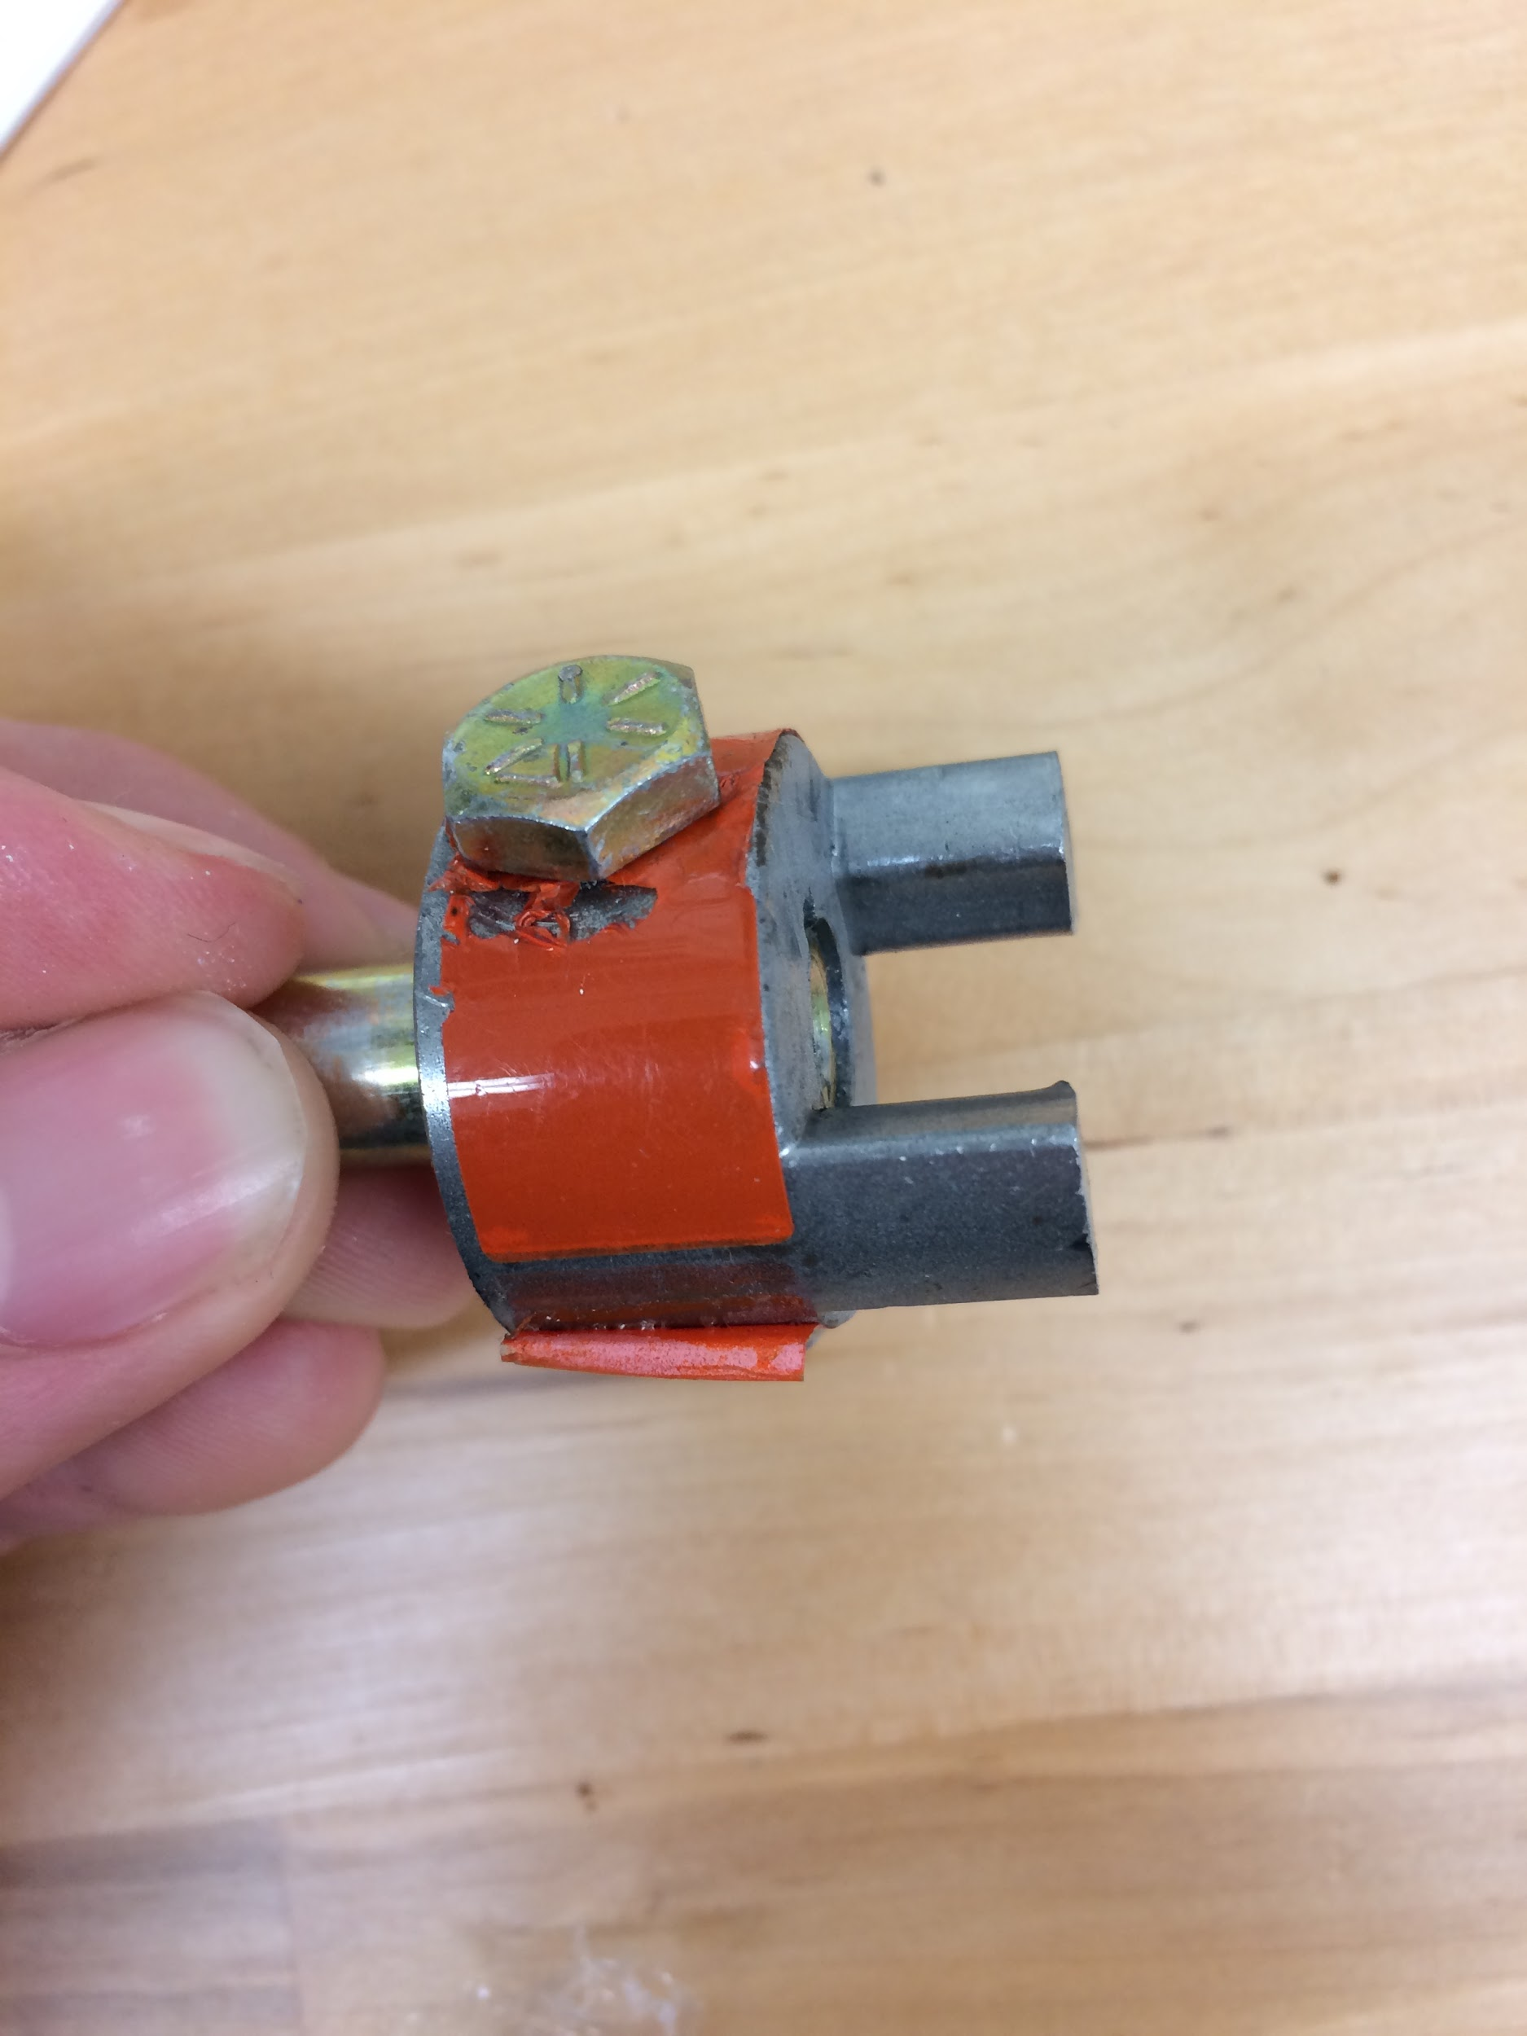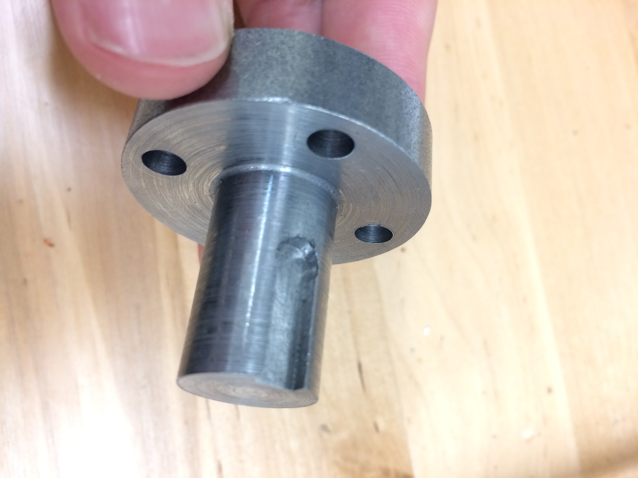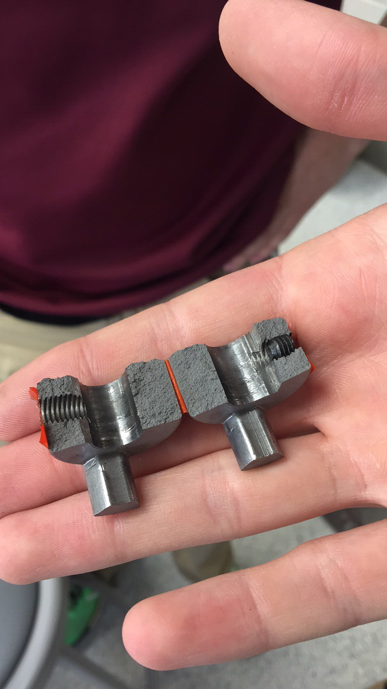

|  |  |  |
| --- | --- | --- |
| Figure 1 - the pinned coupling | Figure 2 - new 16mm shaft design with key and drive hub bolt pattern | Figure 3 - broken lovejoy coupling |

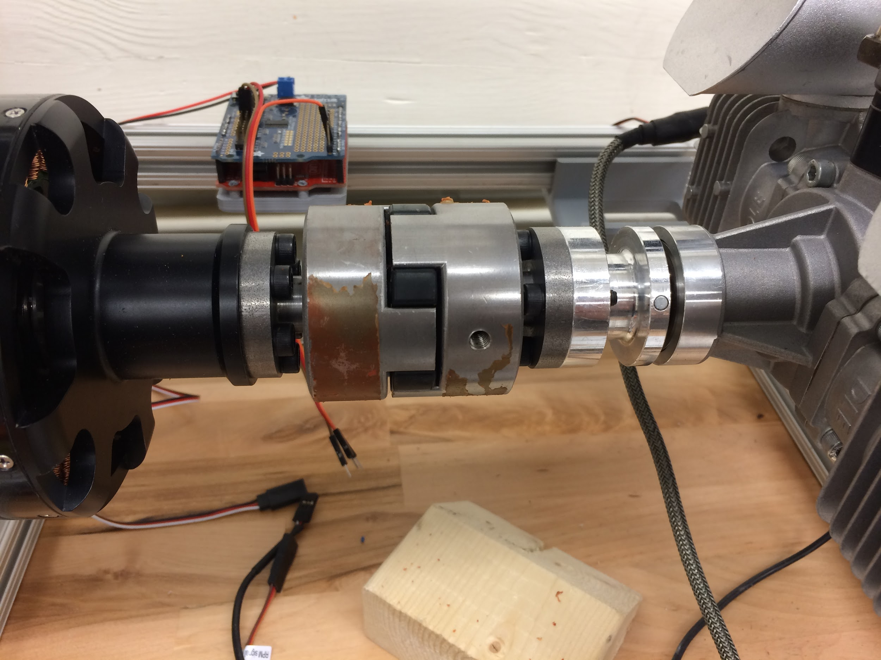

Figure 4 - the beefed up system with new shafts on both the generator and engine side and a larger lovejoy coupling.

**Moving Forward**

Frame Redesign:

The test frame on which the motor-engine system is currently mounted lacks rigidity and is too heavy to mount on the drone. Said lack of rigidity lent itself to shaft misalignment and consequently, failed tests. The new design works to address these two variables (rigidity, mass) by creating an entirely self-contained frame that can be directly attached to the redesigned landing gear (see below). The new frame will be a rectangular prism with parallel 6061 aluminum square faces (8”x8”x0.190”) on which the motor and engine will be mounted, connected on ‘alternating’ planes by 6061 Aluminum 90° angles (1”x1”x1/4”) and cross-braced with 6061 Aluminum bar (1”x1” cs). The connections will be made with 4-hole L brackets. Once bolt holes are drilled into the square faces, excess aluminum will be cut away using a drill press to minimize mass per frame. While carbon fiber was considered in the redesign process, the machinability, rigidity, and ease-of-connection between parts made aluminum the final choice. Further, there was limited proof supporting the notion that the use of carbon fiber would meaningfully change the mass of the system. Finally, the notion of self-containment is most important for mounting the sets on the drone. With an entirely self-contained frame, the system can be treated like a point mass; the mounting points are geometrically balanced to minimize the effects of gyroscopic forces from each system.

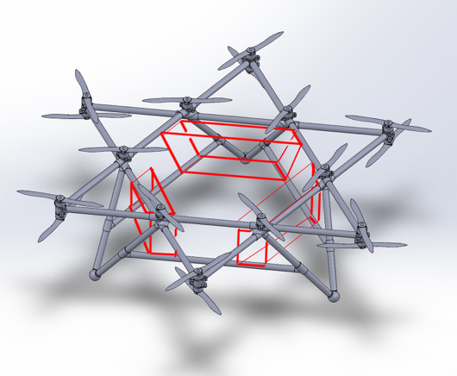

**Figure 2.** Solidworks drawing of drone depicting mounting points of MG-sets

Testing Power Output:

Once mounted, the team can begin testing the power output of the motor-engine system. Using variably-sized heater elements (big resistors), and a constantly overflowing water tank, one can test the voltage drop across the system, ultimately deriving the current flowing to the battery to be charged.

**Appendix A: Schematic of the Gas-Electric Hybrid Power System Components[3] and Component Connections[4]**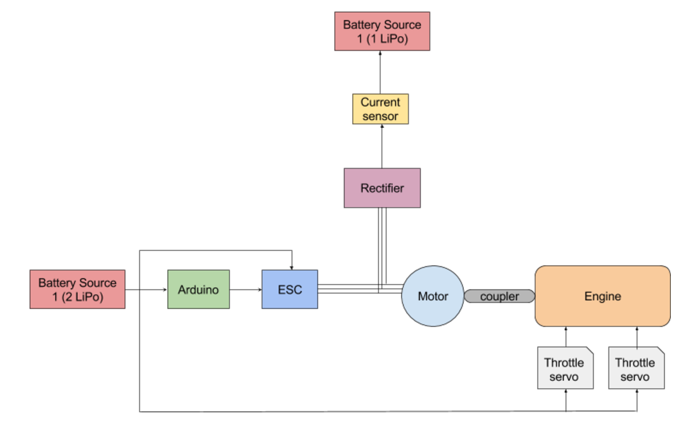

**Figure xx.** A schematic of the power system and its components.

**Appendix A (continued)**

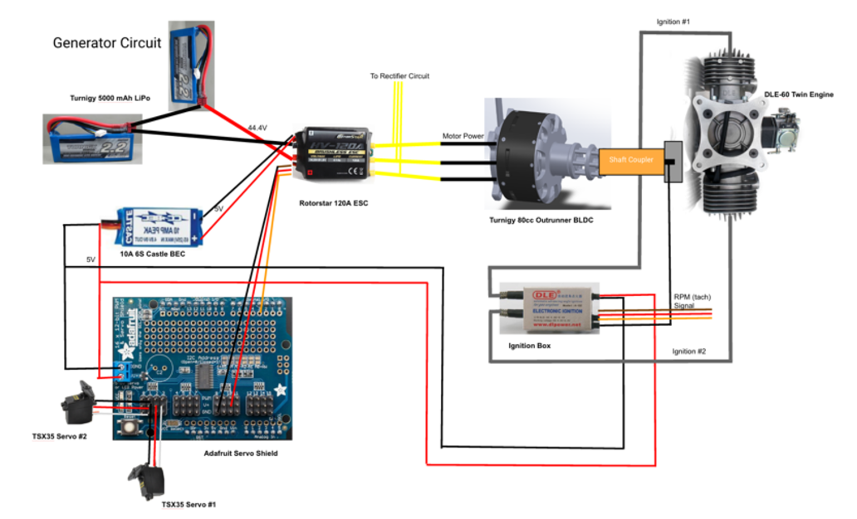

**Figure xx.** The component connections of the system.

1. Overview. Shell Ocean Discovery X-Prize. 2017. By X Prize
2. Block Diagram of Power Flow. *Hybrid Gas-Electric Power Generation for Heavy Lift Drone.* 2016. By Garrett Anderson, Jihane Bettahi, Edward Kim, Tamra Nebabu, Henry Quach, Raiyan Sobhan. 
3. Main Schematic. *Hybrid Gas-Electric Power Generation for Heavy Lift Drone.* 2016. By Garrett Anderson, Jihane Bettahi, Edward Kim, Tamra Nebabu, Henry Quach, Raiyan Sobhan. 
4. Main Connections. *Hybrid Gas-Electric Power Generation for Heavy Lift Drone.* 2016. By Garrett Anderson, Jihane Bettahi, Edward Kim, Tamra Nebabu, Henry Quach, Raiyan Sobhan. 